Team Collaboration Chat Application
By – ADITYA KUMAR DAS (24BET10123)

1. Executive Summary
This document presents a detailed system design proposal for a Team Collaboration Chat Application built using a real-time, event-driven architecture. The system enables instant communication between team members through chat rooms, supports persistent chat history, delivers notifications, and provides administrative controls for user and room management.
The design emphasizes real-time messaging using WebSockets, modular backend services, scalability, maintainability, and clean separation of concerns, making it suitable for both academic evaluation and real-world deployment.

2. Technology Stack
Frontend:
React.js
Backend:
Spring Boot
Spring WebSocket
Database:
MongoDB
Communication Protocol:
WebSockets (STOMP over WebSocket)
Deployment (Conceptual):
Frontend – Vercel
Backend – Render / Cloud VM
Database – MongoDB Atlas

3. High Level Design (HLD)

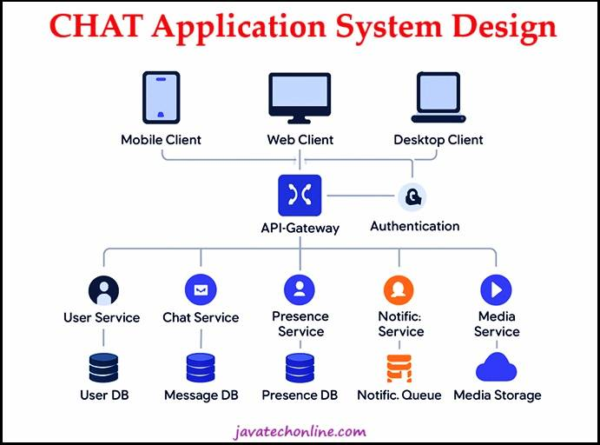
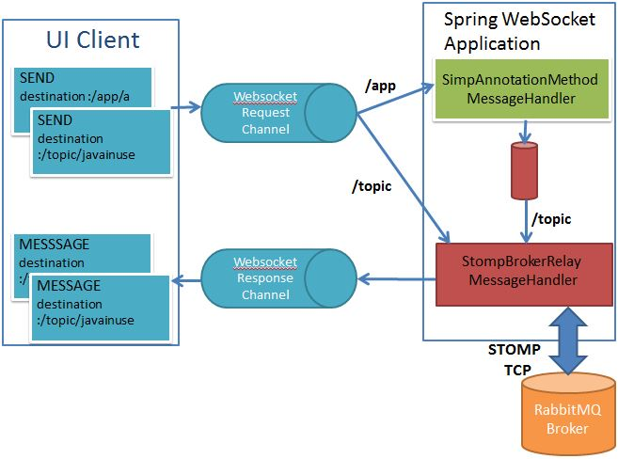
The system follows a client–server architecture with real-time bidirectional communication. A single frontend application communicates with the backend through REST APIs for standard operations and WebSockets for real-time messaging.

High-Level Components
- Frontend Client (React)
- Authentication & User Management Service
- WebSocket Messaging Service
- Chat Room Management Service
- Notification Service
- MongoDB Database
The frontend establishes a persistent WebSocket connection with the backend, enabling low-latency message delivery between connected users.

4. Modular Backend Architecture
The backend is organized into logically separated modules, each responsible for a specific business capability.

Authentication & User Management Module
- Handles user registration and login
- Manages user roles (Admin, Member)
- Validates authenticated users before allowing WebSocket connections

Chat Room Management Module
- Creates and manages chat rooms
- Controls user membership within rooms
- Ensures access control for room participation

Real-Time Messaging Module
- Manages WebSocket connections
- Broadcasts messages to room participants
- Ensures ordered and reliable message delivery

Notification Module
- Tracks unread messages
- Sends real-time notifications for new messages
- Updates notification state when messages are read

Persistence Layer
- Stores users, chat rooms, and messages in MongoDB
- Enables retrieval of historical chat data
All modules are stateless and can be scaled horizontally.

5. Frontend Modules Overview

F1. User Authentication & Interface Module
- Login and logout functionality
- User session management
- Navigation between chat rooms

F2. Chat Room Interface Module
- Displays available chat rooms
- Shows real-time messages
- Allows users to send messages instantly

F3. Notification & Activity Module
- Displays unread message indicators
- Highlights active conversations
- Improves user engagement

6. Low Level Design (LLD)
The backend follows a layered architectural pattern, ensuring separation of concerns and maintainability.

Controller Layer
- Acts as the entry point for HTTP and WebSocket requests
- Handles request validation and response formatting
- Contains no business logic

Service Layer
- Implements all business logic
- Handles message broadcasting, room validation, and notification logic
- Coordinates between repositories and WebSocket sessions

Repository Layer
- Manages data persistence using Spring Data MongoDB
- Handles CRUD operations for users, rooms, and messages

DTO Layer
- Defines request and response objects
- Prevents exposure of internal domain models

Domain Model Layer
- Defines core entities such as:
  - User
  - ChatRoom
  - Message
  - Notification
All real-time messaging logic is centralized in the service layer.

7. Functional Requirements
• User registration and authentication
• Creation and management of chat rooms
• Real-time message delivery via WebSockets
• Persistent chat history
• Notifications for new messages
• Admin-level user and room management

8. Non-Functional Requirements
• Low-latency real-time communication
• Scalability for concurrent users
• Secure user authentication
• High availability and fault tolerance
• Maintainable and modular codebase

9. Evaluation Criteria Mapping
Evaluation Requirement | Implementation
Real-time messaging | WebSockets
Chat history | MongoDB persistence
Admin tools | User & room management modules

10. Conclusion
This proposal outlines a robust Team Collaboration Chat Application designed using modern real-time communication principles. By leveraging React, Spring Boot, WebSockets, and MongoDB, the system delivers instant messaging, persistent chat history, and administrative control. The architecture is scalable, maintainable, and suitable for both academic submission and production-level systems.

